**Program Code**

import java.text.SimpleDateFormat;

import java.util.Date;

class Clock {

// Method to continuously update and print the current time

public static void displayTime() {

// Create a thread for continuously updating the time

Thread updateTimeThread = new Thread(() -> {

while (true) {

try {

// Update the time

updateCurrentTime();

// Sleep for 1 second

Thread.sleep(1000);

} catch (InterruptedException e) {

System.err.println("Error in updateTimeThread: " + e.getMessage());

Thread.currentThread().interrupt();

}

}

});

// Create a thread for printing the time to the console

Thread printTimeThread = new Thread(() -> {

while (true) {

try {

// Print the current time

printCurrentTime();

// Sleep for 1 second

Thread.sleep(1000);

} catch (InterruptedException e) {

System.err.println("Error in printTimeThread: " + e.getMessage());

Thread.currentThread().interrupt();

}

}

});

// Set higher priority for the printTimeThread

printTimeThread.setPriority(Thread.MAX_PRIORITY);

// Start the threads

updateTimeThread.start();

printTimeThread.start();

}

// Method to update the current time

private static synchronized void updateCurrentTime() {

// Get the current time

Date now = new Date();

// Display the time in HH:mm:ss dd-MM-yyyy format

SimpleDateFormat sdf = new SimpleDateFormat("HH:mm:ss dd-MM-yyyy");

System.out.println("Current Time: " + sdf.format(now));

}

// Method to print the current time

private static synchronized void printCurrentTime() {

// Get the current time

Date now = new Date();

// Display the time in HH:mm:ss format

SimpleDateFormat sdf = new SimpleDateFormat("HH:mm:ss");

System.out.println("Time: " + sdf.format(now));

}

public static void main(String[] args) {

// Start displaying the time

displayTime();

}

}

**Program Screenshot**

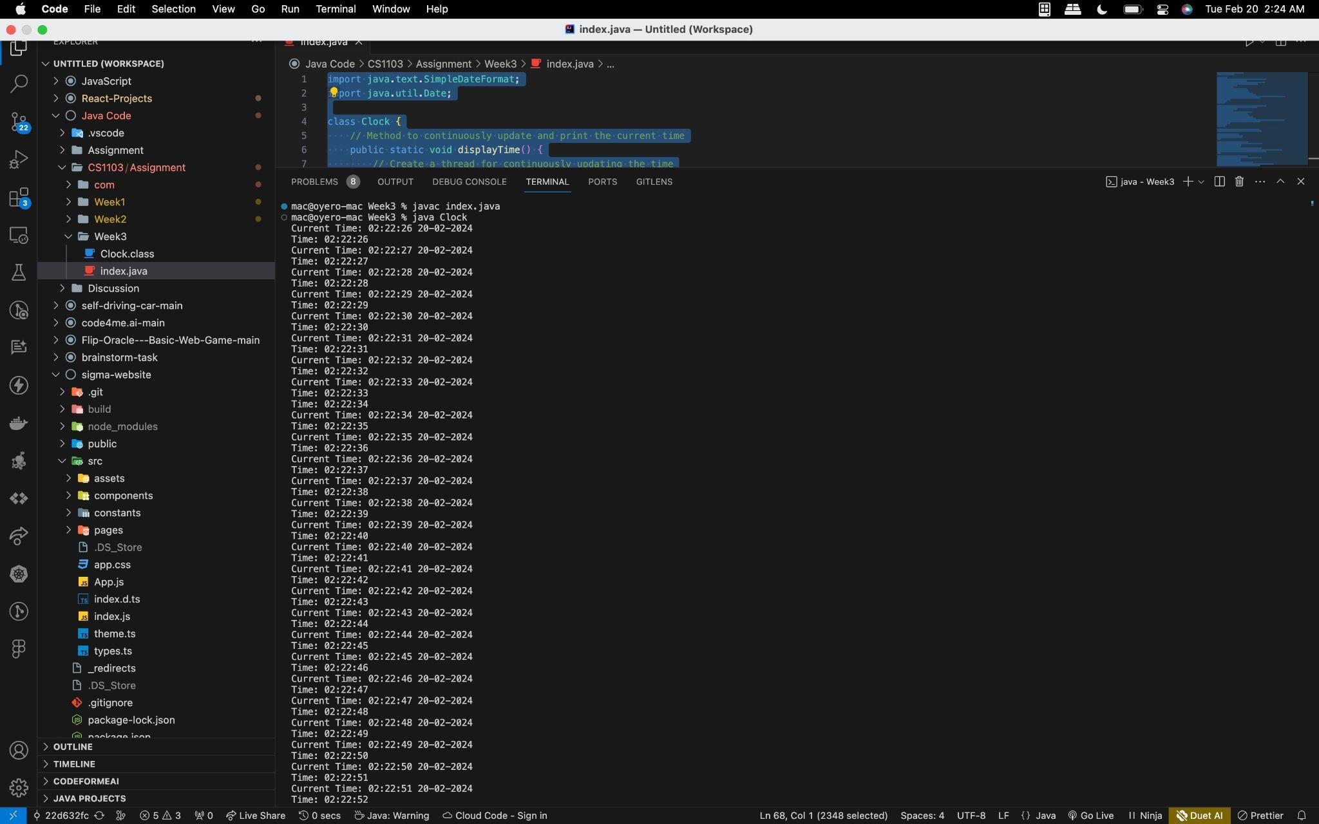

**Program Video**

[Clock-Application.mp4](https://drive.google.com/file/d/1OLNN8d7jy8kbWje_JaeJyXor9t7VhCdV/view?usp=sharing)

**Program Documentation**

## **Overview**

The Clock application is a simple Java program that continuously displays the current time and date. It utilizes Java threads to update the time in the background and print it to the console. Thread priorities are used to ensure better timekeeping precision.

## **Features**

* Displays current time and date in the format "HH:mm:ss dd-MM-yyyy".
* Continuously updates the time in the background.
* Prints the time to the console.
* Utilizes Java threads for concurrency.
* Sets thread priorities for improved timekeeping.

### **Clock Class**

* displayTime(): Method to continuously update and print the current time.
* updateCurrentTime(): Method to update the current time and date.
* printCurrentTime(): Method to print the current time to the console.
* main(): The main method to start the application.

### **Thread Implementation**

* Two separate threads are used: one for updating the time and one for printing it to the console.
* Thread priorities are set to ensure timely console output.